STANDARD STUDENT ATTIRE INFORMATION
2025-2026

All items information listed below is referenced from the Clark County School District Dress Code Regulation 5131.

Permitted Standard Student Attire (SSA) Clothing Items:

Pants/Shorts | Khaki, Navy Blue, Black-Dark Denim  (no tears/rips, no logos/wording, no embellishments)
Long/Short Sleeved Shirts  (must have a collar) | Red, White, Navy Blue, Baby Blue (with or without school logo*)  (NO Black Shirts)
Sweaters | Red, White, Navy Blue, Baby Blue-worn over SSA collared shirts
Non-hooded Sweatshirts | Red, White, Navy Blue, Baby Blue-with or without school logo*, worn over SSA collared shirts
Skirts/Skorts/ Jumpers/Dresses  (all at fingertip length) | Navy Blue, Khaki, Black, Dark Denim
Sweatpants | Navy Blue or Black-on P. E. days only (Plain Color Only)  (no tears/rips, no logos/wording, no embellishments)
Tights/Leggings | Navy Blue, Khaki, White, Black  Must be ankle length and may only be worn under approved clothing-skirts/skorts/jumpers/dresses. Leggings may NOT be worn solely.
Outerwear (Coats) | Does Not need to be in SSA colors but must be removed upon entering the classroom. Administrators/teachers, and staff may use their discretion as appropriate based on the temperature in the facility.
Shoes | No opened toed shoes, no house slippers, shoes must have a back. Shoes with wheels are NOT permitted. All shoes must be securely fastened to the child’s foot.
**Under CCSD Regulation 5131(V-D), “the school logo may only include the school’s name and/or school mascot. No other names or symbols related to school athletic teams, school clubs/activities, charitable organizations, or similar groups/organizations should NOT be on the clothing.”
Not Permitted Standard Student Attire (SSA) Clothing Items:

*Jeans/Denim Pants that have holes, rips, or tears  *Sleeveless Shirts must have a strap at least 3 in wide. | Shirts without Collars (for SSA Schools Only)  No T-Shirts | Hats and Hoods** | Spiked or studded clothing, jewelry, and/or accessories | House slippers and shoes with wheels are not permitted. All shoes must have soles-No opened toed shoes
**Not permitted except for special events, documented medical conditions, bona fide religious reasons, culturally responsive practices, or CCSD/school sanctioned activities. The school Administration shall have right to designate which types of dress, fashion, fads or appearance that disrupts or detracts from educational programs that may be a potential safety hazard. The Principal shall retain the authority to grant exceptions for spirit days and special event dress days. School will notify students and parents/guardians of unique dress provisions.
Uniform Vendors
     | 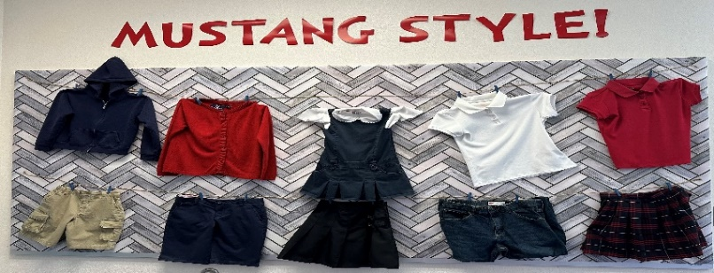 |  |     

